CHAPTER 1

INTRODUCTION OF THE PROJECT

India Trip is being launched because it gives you facility of booking any type of Tours and Travels. As this is an innovative effort to bring different services at one stop, there is no existing system

  - Purpose

The purpose of the project is established fact that Internet users are increasing today. One of the main purpose of the website is to facilitate the offline customer online because customers cannot spend their precious time in markets trying to find out the best deal.
India is a country where in a few days holiday, you can enjoy a lot. The problem is the we although having many websites but they offer different kind of services. The customers are enjoying a lot but there is a lack of relationship between travel agency and customers and hence we are establishing relationship by caring and serving all customers in the same manner that we wish to be served.

  - What is INDIA TRIP all about?

The name itself explains the portal. This is the site of tourism displaying the tourist locations of India only. But can be used by the users across the globe for easy search of various Indian locations, the hotels for accommodation and the travels to go there, book your favorite hotels and travels and get the online confirmation. In this system hotel agent and travel agent can be registered which is help full for visitors to search it. At the beginning the registration for the hotels and the travels will be free. After that the registration will be chargeable for those hotels and travel agents who wish to display their information on this portal. These charges are defined by the Management. According to the charges there will be the validity for the registration. User can register free. Users can also chose hotels and travels within their budget at their favorite places online and get /check the booking confirmation online.

  - Objective

- Our objective is to offer a variety of travel services that are sure to match all your priorities.
- Our objective is to bring different services of tour & travel all at one stop.
- Our objective is to globalism, organize, standardize and goal of journey toward perfectionism.
- Our objective is to make strong relationship with customers so that they can enjoy the holiday of their dreams.
- Our objective is just an initiative, it will be made to more further and developed work of art.

  - Need of Computation

- The hotels, travel agencies can display their information to a wide variety of national and international travelers.
- The project would help in effective and systematic record keeping that is storing and retrieving of useful data.
- Project will be able to give the report so that management can make decisions on the basis of these reports.
- The users can plan their entire tour as per their requirement at home over the internet thus saving time, money and resources.
- Normally at travel agencies at a time only 1 agent handles 1 customer .But this system provides that Multi-User can simultaneously use these services.
- Users can get large amount of information over the portal which is not possible otherwise.
- Users can book their favourite hotel or travel or both at home.
- They can get/check their booking confirmation status.
CHAPTER 2

SOFTWARE REQUIREMENT SPECIFICATION(SRS)

2.1 Introduction

The following subsections of the SRS document provide an overview of the entire SRS.
- Purpose: One of the main purpose of the website is to facilitate the offline customer online because customers cannot spend their precious time in markets trying to find out the best deal.

- Scope: This is the site of tourism displaying the tourist locations of India only. But can be used by the users across the globe for easy search of various Indian locations, the hotels for accommodation and the travels to go there, book your favourite hotels and travels and get the online confirmation. In this system hotel agent and travel agent can be registered which is help full for visitors to search it. At the beginning the registration for the hotels and the travels will be free. After that the registration will be chargeable for those hotels and travel agents who wish to display their information on this portal.. These charges are defined by the Management. According to the charges there will be the validity for the registration. User can register free. Users can also chose hotels and travels within their budget at their favourite places online and get /check the booking confirmation online.

- Overview: The rest of this SRS document describes the various system requirements, interfaces, features and functionalities in detail.

2.2 Overall Description

It is a Commercial web site developed for Customer User Interactions.

The actual process of the registration of hotel and travels is:
The agent of hotel and travel can register with hotel or travel name after that system will sent auto generated mail to the respective with details of payment and the validity and ask for the payment. They have option to choose the validity period .when they pay then manually admin will sent the HOTEL or TRAVEL ID to them. Only this ID will be the valid id. Agent will enter this valid ID, only then agent will be able to display his hotel or travel on site and then registration process will be completed . The information about registration will be stored in to the particular registration table. Hotels and travels can update their details as and when they want.
Before a week of end of validity, system will sent auto generated mail to the agent with validity details and ask for the payment for increasing the validity. Again agent will pay for increase the validity and he can have the validity. If agent do not pay after desired grassing period of validity then system will automatically sent a warning mail and then delete all the data of that agent. In this system we will maintain the payment details date of payment, payment type etc. The payment done is manual.

Present process of the registration of hotel and travels is:

For the promotion of this newly developed portal and to check the user response initially there are no charges for registration. Hotels and travels can register and display their information on this portal for free. It will be valid for 1 year. Meanwhile, as per the response the management will decide upon their charges.
User will able to search the locations even without logging ,.But user has be registered and needs to log in for booking hotel and travels, and also can check the confirmation details only when he has logged . User can have information about a location such as history of location, caves, forts, important places, culture, and climate. The facility of viewing photo gallery and video clippings is also available. The important facility is, user can search the hotels and travels according to his budget. Users can search the hotels taking into consideration his various criteria’s like type of accommodation [Eg:5* Hotel], budget . Users can then book for particular hotel or travel agency and get a confirmation ID. He will also be sent a confirmation mail. He can check the confirmation as and when he wants. Such valuable facilities will be provided by this portal .The travel search result shows the details of the car, about fare, about arrival and departure date time due to this user can arrange his tour very well and without leaving his place all this information he can obtain at his home using internet.

2.3 Hardware and Software Requirement

2.3.1 Front end:

- Java/J2EE technologies (Servlet, JSP)
- HTML
- CSS
- JS
- AJAX

2.3.2 Back end:

- My Sql Database version 5
- Middleware/Server : Apache Tomcat v7.0.
- IDE : NetBeans IDE for Java EE Developers
- Browser : Best result on Mozilla Firefox
- Operating System : Window 7 (Minimum).
- CPU : Core 2 duo
- RAM : 1 GB
- Space on HD : 50 MB.
- Display : CRT, LCD.
2.3.3 Development Tools

- Processor :Intel i5 3rd gen 2.2 GHz or Higher
- RAM :4 GB
- HDD : 80 GB
- OS : Windows 7 and above
- Disked Drive : 3.5” 1.44 MB
- Front end : JSP 2.0
- Back End : MYSQL 5.3.8

2.3.2 Client Side Tools

- Web browser :Internet Explorer 9, Mozilla Firefox 9.0 onwards
- Windows :Microsoft Windows XP professional, Microsoft Windows 7 onwards
- RAM : 2GB
- HDD : 160GB

Server Side Tools

- Processor : Intel Core 2 duo with 2.8 GHz or Higher
- RAM : 2GB
- HDD : 160GB

- Macromedia Dreamweaver 11.0
- Apache Tomcat 7
- JSP version: 2.0
- MYSQL version:

2.4 Tools and Technology

Nowadays various tools as well as technologies are being used for developing such web applications like India Trip (Tour & Travel Management System).While keeping in mind about all these projects have been developed under these technologies. Following technologies are being used in this project:

2.4.1 Core Technology

JAVA

Java is a general purpose, high-level programming language developed by Sun Microsystems. A small team of engineers, known as the Green Team, initiated the language in 1991. Java was originally called OAK, and was designed for handheld devices and set-top boxes. Oak was unsuccessful, so in 1995 Sun changed the name to Java and modified the language to take advantage of the burgeoning World Wide Web.
Later, in 2009, Oracle Corporation acquired Sun Microsystems and took ownership of two key Sun software assets: Java and Solaris.

Java: An Object-Oriented Language

Java is an object-oriented language similar to C++, but simplified to eliminate language features that cause common programming errors. Java source code files (files with a .java extension) are compiled into a format called bytecode (files with a .class extension), which can then be executed by a Java interpreter. Compiled Java code can run on most computers because Java interpreters and runtime environments, known as Java Virtual Machines (VMs), exist for most operating systems, including UNIX, the Macintosh OS, and Windows. Byte code can also be converted directly into machine language instructions by a just-in-time compiler (JIT). In 2007, most Java technologies were released under the GNU General Public License.

Java on the Web

Java is a general purpose programming language with a number of features that make the language well suited for use on the World Wide Web. Small Java applications are called Java applets and can be downloaded from a Web server and run on your computer by a Java compatible Web browser.
Applications and websites using Java will not work unless Java is installed on your device. When you download Java, the software contains the Java Runtime Environment (JRE) which is needed to run in a Web browser. A component of the JRE, the Java Plug-in software allows Java applets to run inside various browsers.

J2EE

Java Platform, Enterprise Edition or Java EE is Oracle's enterprise Java computing platform. The platform provides an API and runtime environment for developing and running enterprise software, including network and web services, and other large-scale, multi-tiered, scalable, reliable, and secure network applications. Java EE extends the Java Platform, Standard Edition (Java SE), providing an API for object-relational mapping, distributed and multi-tier architectures, and web services.
The platform incorporates a design based largely on modular components running on an application server. Software for Java EE is primarily developed in the Java programming language. The platform emphasizes Convention over configuration and annotations for configuration. Optionally XML can be used to override annotations or to deviate from the platform defaults.
Servlet

The servlet is a Java programming language class used to extend the capabilities of a server. Although servlets can respond to any types of requests, they are commonly used to extend the applications hosted by web servers, so they can be thought of as Java applets that run on servers instead of in web browsers. These kinds of servlets are the Java counterpart to other dynamic Web content technologies such as PHP and ASP.NET.

HTML

HTML or Hypertext Markup Language is the standard markup language used to create web pages. HTML is written in the form of HTML elements consisting of tags enclosed in angle brackets (like <html>). HTML tags most commonly come in pairs like <h1> and </h1>, although some tags represent empty elements and so are unpaired, for example <img>. The first tag in a pair is the start tag, and the second tag is the end tag (they are also called opening tags and closing tags).
A web browser can read HTML files and compose them into visible or audible web pages. The browser does not display the HTML tags, but uses them to interpret the content of the page. HTML describes the structure of a website semantically along with cues for presentation, making it a markup language rather than a programming language.
HTML elements form the building blocks of all websites. HTML allows images and objects to be embedded and can be used to create interactive forms. It provides a means to create structured documents by denoting structural semantics for text such as headings, paragraphs, lists, links, quotes and other items. It can embed scripts written in languages such as JavaScript which affect the behaviour of HTML web pages.
Web browsers can also refer to Cascading Style Sheets (CSS) to define the look and layout of text and other material. The W3C, maintainer of both the HTML and the CSS standards, encourages the use of CSS over explicit presentational HTML.

JDBC

JDBC is a Java-based data access technology (Java Standard Edition platform) from Oracle Corporation. This technology is an API for the Java programming language that defines how a client may access a database. It provides methods for querying and updating data in a database. JDBC is oriented towards relational databases. A JDBC to ODBC Bridge enables connections to any ODBC-accessible data source in the JVM host environment.

CSS

Cascading Style Sheets (CSS) is a style sheet language used for describing the look and formatting of a document written in a markup language. While most often used to style web pages and user interfaces written in HTML and XHTML, the language can be applied to any kind of XML document, including plain XML, SVG and XUL. CSS is a cornerstone specification of the web and almost all web pages use CSS style sheets to describe their presentation.
CSS is designed primarily to enable the separation of document content from document presentation, including elements such as the layout, colours, and fonts. This separation can improve content accessibility, provide more flexibility and control in the specification of presentation characteristics, enable multiple pages to share formatting, and reduce complexity and repetition in the structural content (such as by allowing for table less web design). It obviates those portions of markup that would specify presentation by instead providing that information in a separate file. For each relevant HTML element (identified by tags), it provides a list of formatting instructions. For example, it might say (in CSS syntax), "All heading 1 elements should be bold." Therefore, no formatting markup such as bold tags (<b></b>) is needed within the content; what is needed is simply semantic markup saying, “this text is a level 1 heading."
CSS can also allow the same markup page to be presented in different styles for different rendering methods, such as on-screen, in print, by voice (when read out by a speech-based browser or screen reader) and on Braille-based, tactile devices. It can also be used to allow the web page to display differently depending on the screen size or device on which it is being viewed. While the author of a document typically links that document to a CSS file, readers can use a different style sheet, perhaps one on their own computer, to override the one the author has specified. However if the author or the reader did not link the document to a specific style sheet the default style of the browser will be applied.

JSP

- Java Server Pages (JSP) is a technology that helps software developers create dynamically generated web pages based on HTML, XML, or other document types. Released in 1999 by Sun Microsystems, JSP is similar to PHP, but it uses the Java programming language.
- JSP may be viewed as a high-level abstraction of Java servlets. JSPs are translated into servlets at runtime; each JSP servlet is cached and re-used until the original JSP is modified.
- JSP can be used independently or as the view component of a server-side model–view– controller design, normally with JavaBeans as the model and Java servlets (or a framework such as Apache Struts) as the controller. This is a type of Model 2 architecture.
- JSPs are usually used to deliver HTML and XML documents, but through the use of Output Stream, they can deliver other types of data as well.
- The Web container creates JSP implicit objects like page Context, servlet Context, session, request & response.

JAVA Script

A scripting language developed by Netscape to enable Web authors to design interactive sites. Although it shares many of the features and structures of the full Java language, it was developed independently. Java script can interact with HTML source code, enabling Web authors to spice up their sites with dynamic content. JavaScript is endorsed by a number of software companies and is an open language that anyone can use without purchasing a license. It is supported by recent browsers from Netscape and Microsoft, though Internet Explorer supports only a subset, which Microsoft calls Jscript.

MYSQL

‘MYSQL’ the most popular ‘open source’ SQL database management system is developed, distributed and supported by ‘MYSQL ‘AB’.’MYSQL AB’ is a commercial company, founded by the MYSQL developers that build its business by providing services around the ‘MYSQL’ database management system.
‘MYSQL’ is a database management system. A database is a structured collection of a data. It may be anything from a simple shopping list to a picture gallery or the vast amount of information in the corporate network. To add, access, and process data store in a computer database, you need a database management system such as ‘MYSQL ‘server. Since computer are very good at handling large amount of data, database, management systems play a central role in computing, as stand-alone utilities or as part of other application.
- MYSQL is Database server.
- MYSQL is ideal for both small and large application.
- MYSQL support standard SQL.
- MYSQL complies on a number of platforms.
- MYSQL is free to download and use.

Why use The MYSQL database server:

The ‘MYSQL’ database server is very fast, reliable and easy to use. If that is what you are looking for, you should give it a try. ‘MYSQL’ server also has a practical set features developed in close cooperation with users. You can find a performance comparison of ‘MYSQL’ server with other database managers on our benchmark page. ’MYSQL’ was originally developed to handle large database much faster than existing solution and has been successfully use in highly demanding production environments for several years.

My SQL Database V 5.0 :

My SQL Database V5.0 is a free version of the world's most capable relational database. It is easy to install, easy to manage, and easy to develop with.
With My SQL Database V5.0, you use an intuitive, browser-based interface, to:
- Administer the database
- Create tables, views, and other database objects
- Import, export, and view table data
- Run queries and SQL scripts
- Generate reports

Apache Tomcat v7.0.

Apache Tomcat (or simply Tomcat, formerly also Jakarta Tomcat) is an open source web server and servlet container developed by the Apache Software Foundation (ASF). Tomcat implements the Java Servlet and the Java Server Pages (JSP) specifications from Sun Microsystems, and provides a "pure Java" HTTP web server environment for Java code to run in. In the simplest configuration Tomcat runs in a single operating system process. The process runs a Java virtual machine (JVM). Every single HTTP request from a browser to Tomcat is processed in the Tomcat process in a separate thread.

CHAPTER 3

SYSTEM DESIGN

  - Introduction

Software design sits at the technical kernel of the software engineering process and is applied regardless of the development paradigm and area of application. Design is the first step in the development phase for any engineered product or system. The designer’s goal is to produce a model or representation of an entity that will later be built. Beginning, once system requirement have been specified and analysed, system design is the first of the three technical activities design, code and test that is required to build and verify software.
The importance can be stated with a single word “Quality”. Design is the place where quality is fostered in software development. Design provides us with representations of software that can assess for quality. Design is the only way that we can accurately translate a customer’s view into a finished software product or system. Software design serves as a foundation for all the software engineering steps that follow. Without a strong design we risk building an unstable system – one that will be difficult to test, one whose quality cannot be assessed until the last stage.
During design, progressive refinement of data structure, program structure, and procedural details are developed reviewed and documented. System design can be viewed from either technical or project management perspective. From the technical point of view, design is comprised of four activities – architectural design, data structure design, interface design and procedural design.

3.2 Normalization

It is a process of converting a relation to a standard form. The process is used to handle the problems that can arise due to data redundancy i.e. repetition of data in the database, maintain data integrity as well as handling problems that can arise due to insertion, updating, deletion anomalies.
Decomposing is the process of splitting relations into multiple relations to eliminate anomalies and maintain anomalies and maintain data integrity. To do this we use normal forms or rules for structuring relation.

First Normal Form:

A relation is said to be in first normal form if the values in the relation are atomic for every attribute in the relation. By this we mean simply that no attribute value can be a set of values or, as it is sometimes expressed, a repeating group.

Second Normal Form:

A relation is said to be in second Normal form is it is in first normal form and it should satisfy any one of the following rules.
- Primary key is a not a composite primary key
- No non key attributes are present
- Every non key attribute is fully functionally dependent on full set of primary key.

Third Normal Form:

A relation is said to be in third normal form if their exits no transitive dependencies.
Transitive Dependency: If two non-key attributes depend on each other as well as on the primary key then they are said to be transitively dependent. The above normalization principles were applied to decompose the data in multiple tables thereby making the data to be maintained in a consistent state.

3.3 E-R Diagram

The relation upon the system is structure through a conceptual ER-Diagram, which not only specifics the existential entities but also the standard relations through which the system exists and the cardinalities that are necessary for the system state to continue.
The entity Relationship Diagram (ERD) depicts the relationship between the data objects. The ERD is the notation that is used to conduct the date modelling activity the attributes of each data object noted is the ERD can be described resign a data object descriptions.

ER DIAGRAM
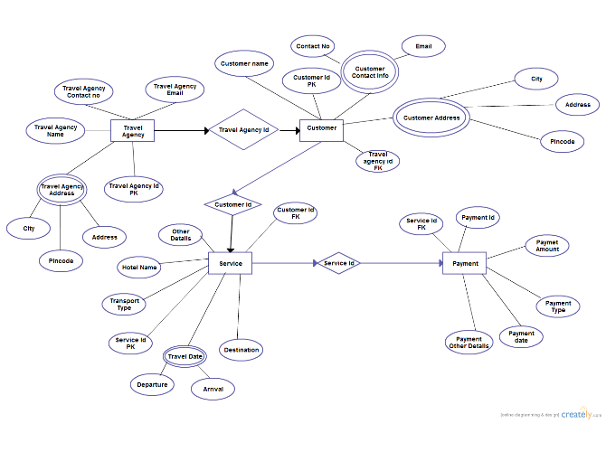

Figure 3.1 Entity Relationship Diagram for the proposed system of India Trip

3.4 Data Flow Diagrams (DFDs)

- A data flow diagram is graphical tool used to describe and analyse movement of data through a system. These are the central tool and the basis from which the other components are developed. The transformation of data from input to output, through processed, may be described logically and independently of physical components associated with the system. These are known as the logical data flow diagrams. The physical data flow diagrams show the actual implements and movement of data between people, departments and workstations. A full description of a system actually consists of a set of data flow diagrams.
- Using two familiar notations Yourdon, Gane and Sarson notation develops the data flow diagrams. Each component in a DFD is labelled with a descriptive name. Process is further identified with a number that will be used for identification purpose.
- The development of DFD’S is done in several levels. Each process in lower level diagrams can be broken down into a more detailed DFD in the next level. The lop-level diagram is often called context diagram. It consists a single process bit, which plays vital role in studying the current system. The process in the context level diagram is exploded into other process at the first level DFD.
- The idea behind the explosion of a process into more process is that understanding at one level of detail is exploded into greater detail at the next level. This is done until further explosion is necessary and an adequate amount of detail is described for analyst to understand the process.
- Larry Constantine first developed the DFD as a way of expressing system requirements in a graphical from, this lead to the modular design.A DFD is also known as a “bubble Chart” has the purpose of clarifying system requirements and identifying major transformations that will become programs in system design. So it is the starting point of the design to the lowest level of detail. A DFD consists of a series of bubbles joined by data flows in the system.

DFD SYMBOLS:
In the DFD, there are four symbols
- A square defines a source (originator) or destination of system data
- An arrow identifies data flow. It is the pipeline through which the information flows
- A circle or a bubble represents a process that transforms incoming data flow into outgoing data flows.
- An open rectangle is a data store, data at rest or a temporary repository of data.

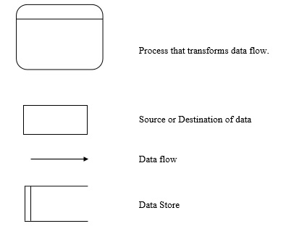

CONSTRUCTING A DFD:

Several rules of thumb are used in drawing DFD’S:
- Process should be named and numbered for an easy reference. Each name should be representative of the process.
- The direction of flow is from top to bottom and from left to right. Data traditionally flow from source to the destination although they may flow back to the source.
- One way to indicate this is to draw long flow line back to a source. An alternative way is to repeat the source symbol as a destination. Since it is used more than once in the DFD it is marked with a short diagonal.
- When a process is exploded into lower level details, they are numbered.
- The names of data stores and destinations are written in capital letters. Process and dataflow names have the first letter of each work capitalized.
A DFD typically shows the minimum contents of data store. Each data store should contain all the data elements that flow in and out.
Questionnaires should contain all the data elements that flow in and out. Missing interfaces redundancies and like is then accounted for often through interviews.

SALIENT FEATURES OF DFD’S

- The DFD shows flow of data, not of control loops and decision are controlled considerations do not appear on a DFD.
- The DFD does not indicate the time factor involved in any process whether the dataflow take place daily, weekly, monthly or yearly.
- The sequence of events is not brought out on the DFD.

TYPES OF DATA FLOW DIAGRAMS
- Current Physical
- Current Logical
- New Logical
- New Physical

Current Physical:
In Current Physical DFD process label include the name of people or their positions or the names of computer systems that might provide some of the overall system-processing label includes an identification of the technology used to process the data.
Similarly data flows and data stores are often labels with the names of the actual physical media on which data are stored such as file folders, computer files, business forms or computer tapes.

Current Logical:
The physical aspects at the system are removed as much as possible so that the current system is reduced to its essence to the data and the processors that transforms them regardless of actual physical form.

New Logical:
This is exactly like a current logical model if the user were completely happy with the user were completely happy with the functionality of the current system but had problems with how it was implemented typically through the new logical model will differ from current logical model while having additional functions, absolute function removal and inefficient flows recognized.
New Physical:
The new physical represents only the physical implementation of the new system.

Rules Governing the DFD’s
Process
- No process can have only outputs.
- No process can have only inputs. If an object has only inputs than it must be a sink.
- A process has a verb phrase label.
Data Store
- Data cannot move directly from one data store to another data store, a process must move data.
- Data cannot move directly from an outside source to a data store, a process, which receives, must move data from the source and place the data into data store
- A data store has a noun phrase label.

Data Flow
- A Data Flow has only one direction of flow between symbols. It may flow in both directions between a process and a data store to show a read before an update. The later is usually indicated however by two separate arrows since these happen at different type.
- A join in DFD means that exactly the same data comes from any of two or more different processes data store or sink to a common location.
- A data flow cannot go directly back to the same process it leads. There must be at least one other process that handles the data flow produce some other data flow returns the original data into the beginning process.
- A Data flow to a data store means update (delete or change).
- A data Flow from a data store means retrieve or use.

LEVEL ‘0’ DFD for India Trip
User /Admin.

Indiatrip.com 0.0
User /Admin.
Home Page
Thanks Page

Figure 3.2 Data Flow Diagram level 0 for the India Trip

LEVEL ‘1’ DFD

User:
User
Registration

Registration

Travel Registration

Searching
Module

Home Page 1.0
User
Login

Hotel
Registration

Booking

Confirmation

Figure 3.3 Data Flow Diagram level 1 for user

Class Diagram
User Registration
UserId
Password
UserName
Gender
Fax
RegDate
Registration
Password: varchar
Address: varchar
City: varchar
State: varchar
Country: varchar
Pin: bigint
Phone: bigint
Mobile bigint
Email: varchar

Travel Registration
TravelId
Password
Web Site
RegDate
ValidUpTo
Hotel Registration
HotelId
Password
Hotelname
Type
Fax
WebSite
RegDate
ValidUpTo
Location Registration
LocationId
Climate
Culture
Booking
HtlBookId
HtlConfirId
HtlId
HtlName
Search
Hotel Name
Location
Room
Room No
Type
status
car
Car No
Type
Shedule

Figure 3. 4 Class Diagram for India Trip

CHAPTER 4

PROJECT DESCRIPTION

4.1 Introduction

India Trip Project includes the following modules:
- Admin
- User Module
- Registration Module
- Search Module
- Booking Module
- Confirmation Module

Users can able to perform Transactions like
Maintaining the details in master file which can be easily Update
Keeping Transactions Like:
- Registration
- Update Details
- Search for Hotels, Travels and Locations.
- View the locations image gallery and video clips.
- View the history, culture, climate etc of the locations.
- View the places for visit in that location.
- Book Hotels and Travels Online.
- Get / Check Booking confirmation status.

Hotel can perform Transactions like
- Registration
- Update details.
- Update validity.
- Payment gate way.[Proposed]
- User Booking.
- Sending Booking Confirmation to user.
Travel agency can perform Transactions like
- Registration
- Update details.
- Update validity.
- Payment gate way[Proposed]
- User Booking.
- Sending Booking Confirmation to user.
Admin can perform Transactions like :
- Check for the registration payment.
- Assign a unique registration ID to the hotels and travels.
- Renew their validity.
- Check the reports periodically.
- Enter the location details.

CHAPTER 5

SYSTEM TESTING AND MANIPULATION

5.1 Introduction

Software testing is a critical element of software quality assurance and represents the ultimate review of specification, design and coding. In fact, testing is the one step in the software engineering process that could be viewed as destructive rather than constructive.
A strategy for software testing integrates software test case design methods into a well-planned series of steps that result in the successful construction of software. Testing is the set of activities that can be planned in advance and conducted systematically.
The underlying motivation of program testing is to affirm software quality with methods that can economically and effectively apply to both strategic to both large and small-scale systems.

5.2 Strategic Approach to Software Testing

The software engineering process can be viewed as a spiral. Initially system engineering defines the role of software and leads to software requirement analysis where the information domain, functions, behaviour, performance, constraints and validation criteria for software are established. Moving inward along the spiral, we come to design and finally to coding. To develop computer software we spiral in along streamlines that decrease the level of abstraction on each turn.
A strategy for software testing may also be viewed in the context of the spiral. Unit testing begins at the vertex of the spiral and concentrates on each unit of the software as implemented in source code.
Testing progress by moving outward along the spiral to integration testing, where the focus is on the design and the construction of the software architecture.
Talking another turn on outward on the spiral we encounter validation testing where requirements established as part of software requirements analysis are validated against the software that has been constructed.
Finally we arrive at system testing, where the software and other system elements are tested as a whole.
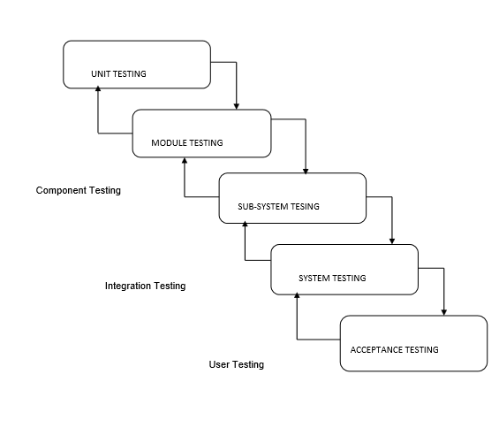
Figure 5.1: Types of Testing

5.3 Unit Testing
Unit testing focuses verification effort on the smallest unit of software design, the module. The unit testing we have is white box oriented and some modules the steps are conducted in parallel.

5.3.1 White Box Testing
This type of testing ensures that
- All independent paths have been exercised at least once
- All logical decisions have been exercised on their true and false sides
- All loops are executed at their boundaries and within their operational bounds
- All internal data structures have been exercised to assure their validity.

To follow the concept of white box testing we have tested each form .we have created independently to verify that Data flow is correct, All conditions are exercised to check their validity, All loops are executed on their boundaries.

5.3.2 Basic Path Testing
Established technique of flow graph with cyclomatic complexity was used to derive test cases for all the functions. The main steps in deriving test cases were:
Use the design of the code and draw correspondent flow graph.
Determine the cyclomatic complexity of resultant flow graph, using formula:
V(G)=E-N+2 or
V(G)=P+1 or
V(G)=Number Of Regions
Where V(G) is cyclomatic complexity,
E is the number of edges,
N is the number of flow graph nodes,
P is the number of predicate nodes.
Determine the basis of set of linearly independent paths.

5.3.3 Conditional Testing

In this part of the testing each of the conditions were tested to both true and false aspects. And all the resulting paths were tested. So that each path that may be generate on particular condition is traced to uncover any possible errors.

5.3.4 Data Flow Testing

This type of testing selects the path of the program according to the location of definition and use of variables. This kind of testing was used only when some local variable were declared. The definition-use chain method was used in this type of testing. These were particularly useful in nested statements.

5.3.5 Loop Testing
- In this type of testing all the loops are tested to all the limits possible. The following exercise was adopted for all loops:
- All the loops were tested at their limits, just above them and just below them.
- All the loops were skipped at least once.
- For nested loops test the inner most loop first and then work outwards.
- For concatenated loops the values of dependent loops were set with the help of connected loop.
- Unstructured loops were resolved into nested loops or concatenated loops and tested as above.
- Each unit has been separately tested by the development team itself and all the input have been validated.

5.3.6 Prototype Models used in Project

The Prototyping Model is a systems development method (SDM) in which a prototype (an early approximation of a final system or product) is built, tested, and then reworked as necessary until an acceptable prototype is finally achieved from which the complete system or product can now be developed. This model works best in scenarios where not all of the project requirements are known in detail ahead of time. It is an iterative, trial-and-error process that takes place between the developers and the users.
There are several steps in the Prototyping Model:
- The new system requirements are defined in as much detail as possible. This usually involves interviewing a number of users representing all the departments or aspects of the existing system.
- A preliminary design is created for the new system.
- A first prototype of the new system is constructed from the preliminary design. This is usually a scaled-down system, and represents an approximation of the characteristics of the final product.
- The users thoroughly evaluate the first prototype, noting its strengths and weaknesses, what needs to be added, and what should to be removed. The developer collects and analyzes the remarks from the users.
- The first prototype is modified, based on the comments supplied by the users, and a second prototype of the new system is constructed.
- The second prototype is evaluated in the same manner as was the first prototype.
- The preceding steps are iterated as many times as necessary, until the users are satisfied that the prototype represents the final product desired.
- The final system is constructed, based on the final prototype.
- The final system is thoroughly evaluated and tested. Routine maintenance is carried out on a continuing basis to prevent large-scale failures and to minimize downtime.

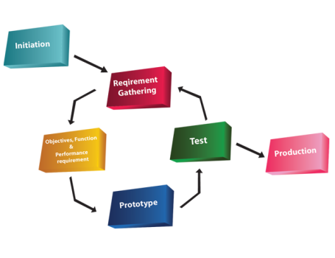

Figure. 5.2 Prototype Model for testing

CHAPTER 6

SYSTEM SECURITY

6.1 Introduction

The protection of computer based resources that includes hardware, software, data, procedures and people against unauthorized use or natural
Disaster is known as System Security.
System Security can be divided into four related issues:
- Security
- Integrity
- Privacy
- Confidentiality

System Security refers to the technical innovations and procedures applied to the hardware and operation systems to protect against deliberate or accidental damage from a defined threat.
Data Security is the protection of data from loss, disclosure, modification and destruction.
System Integrity refers to the power functioning of hardware and programs, appropriate physical security and safety against external threats such as eavesdropping and wiretapping.
Privacy defines the rights of the user or organizations to determine what information they are willing to share with or accept from others and how the organization can be protected against unwelcome, unfair or excessive dissemination of information about it.
Confidentiality is a special status given to sensitive information in a database to minimize the possible invasion of privacy. It is an attribute of information that characterizes its need for protection.

6.2 Security Software

System security refers to various validations on data in form of checks and controls to avoid the system from failing. It is always important to ensure that only valid data is entered and only valid operations are performed on the system. The system employees two types of checks and controls:

Client Side Validation

Various client side validations are used to ensure on the client side that only valid data is entered. Client side validation saves server time and load to handle invalid data. Some checks imposed are:
- JavaScript in used to ensure those required fields are filled with suitable data only. Maximum lengths of the fields of the forms are appropriately defined.
- Forms cannot be submitted without filling up the mandatory data so that manual mistakes of submitting empty fields that are mandatory can be sorted out at the client side to save the server time and load.
- Tab-indexes are set according to the need and taking into account the ease of user while working with the system.

Server Side Validation

Some checks cannot be applied at client side. Server side checks are necessary to save the system from failing and intimating the user that some invalid operation has been performed or the performed operation is restricted. Some of the server side checks imposed is:
- Server side constraint has been imposed to check for the validity of primary key and foreign key. A primary key value cannot be duplicated. Any attempt to duplicate the primary value results into a message intimating the user about those values through the forms using foreign key can be updated only of the existing foreign key values.

- User is intimating through appropriate messages about the successful operations or exceptions occurring at server side.

- Various Access Control Mechanisms have been built so that one user may not agitate upon another. Access permissions to various types of users are controlled according to the organizational structure. Only permitted users can log on to the system and can have access according to their category. User- name, passwords and permissions are controlled o the server side.

- Using server side validation, constraints on several restricted operations are imposed.

CHAPTER 7

CONCLUSION

It has been a great pleasure for me to work on this exciting and challenging project. This project proved good for me as it provided practical knowledge of not only programming in JAVA and MySQL web based application and to some extent Windows Application and SQL Server, but also about all handling procedure related with “India Trip”. It also provides knowledge about the latest technology used in developing web enabled application and client server technology that will be great demand in future. This will provide better opportunities and guidance in future in developing projects independently.

  - Benefits

The project is identified by the merits of the system offered to the user. The merits of this project are as follows: -
- It’s a web-enabled project.
- This project offers user to enter the data through simple and interactive forms. This is very helpful for the client to enter the desired information through so much simplicity.
- The user is mainly more concerned about the validity of the data, whatever he is entering. There are checks on every stages of any new creation, data entry or updation so that the user cannot enter the invalid data, which can create problems at later date.
- Sometimes the user finds in the later stages of using project that he needs to update some of the information that he entered earlier. There are options for him by which he can update the records. Moreover there is restriction for his that he cannot change the primary data field. This keeps the validity of the data to longer extent.
- User is provided the option of monitoring the records he entered earlier. He can see the desired records with the variety of options provided by him.
- Decision making process would be greatly enhanced because of faster processing of information since data collection from information available on computer takes much less time than manual system.
- Easier and faster data transfer through latest technology associated with the computer and communication.
- Through these features it will increase the efficiency, accuracy and transparency.

  - Limitations

- The size of the database increases day-by-day, increasing the load on the database back up and data maintenance activity.
- Training for simple computer operations is necessary for the users working on the system.

CHAPTER 8

SCREENSHOT

Home page

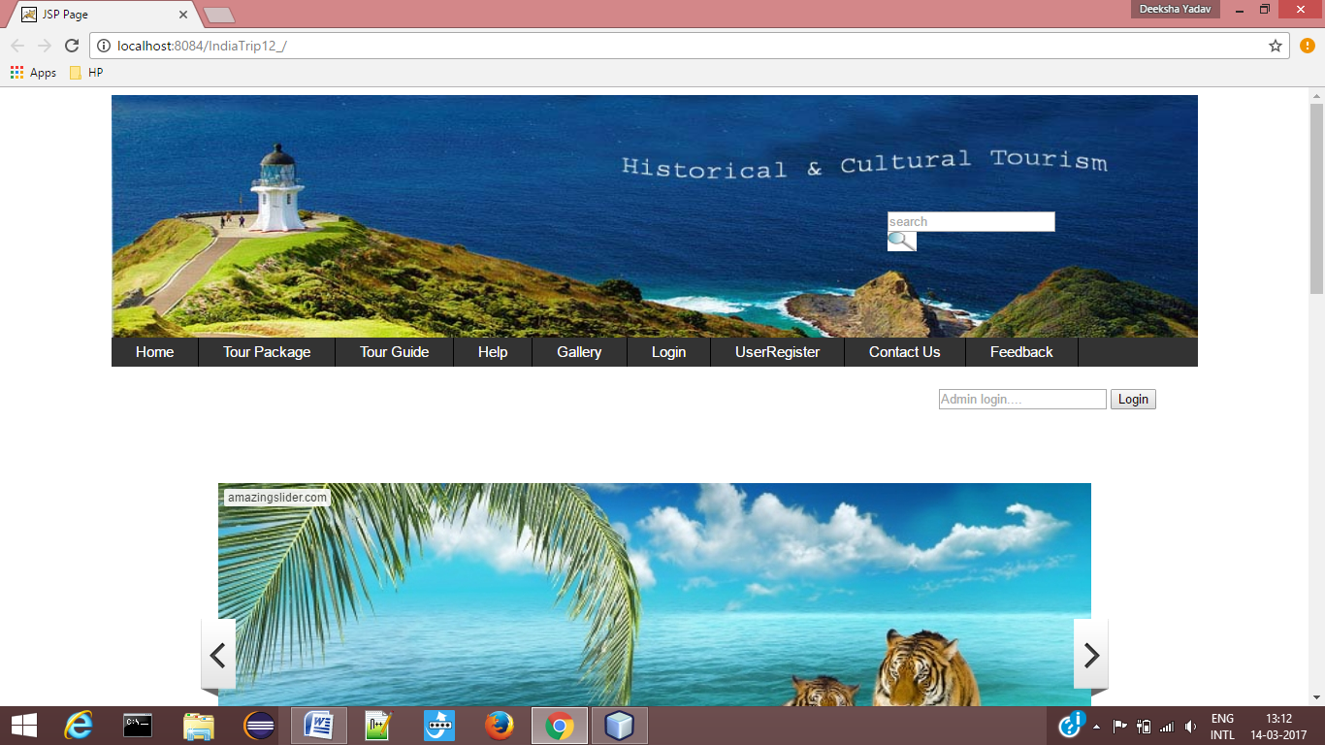

Screenshot 8.1 : Home Page for India Trip

User Registration

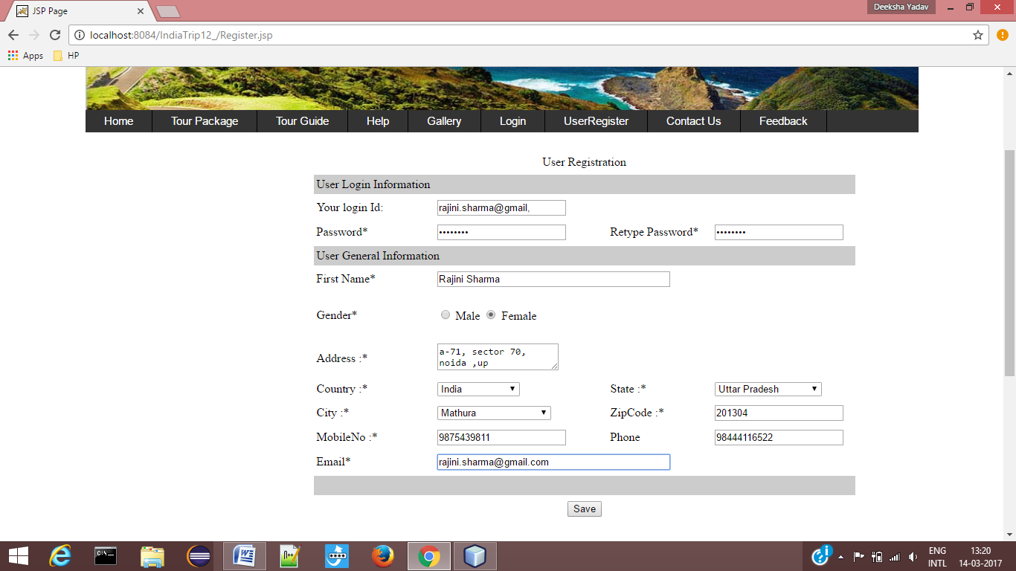

Screenshot 8.2: For User Registration

Book Hotel

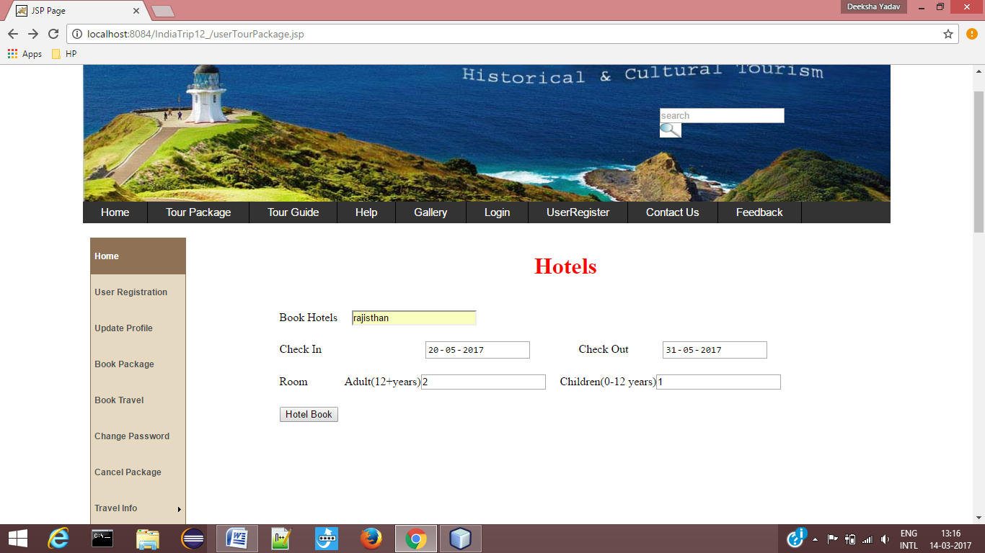

Screenshot 8.3 : Book Hotel

Travel Registration

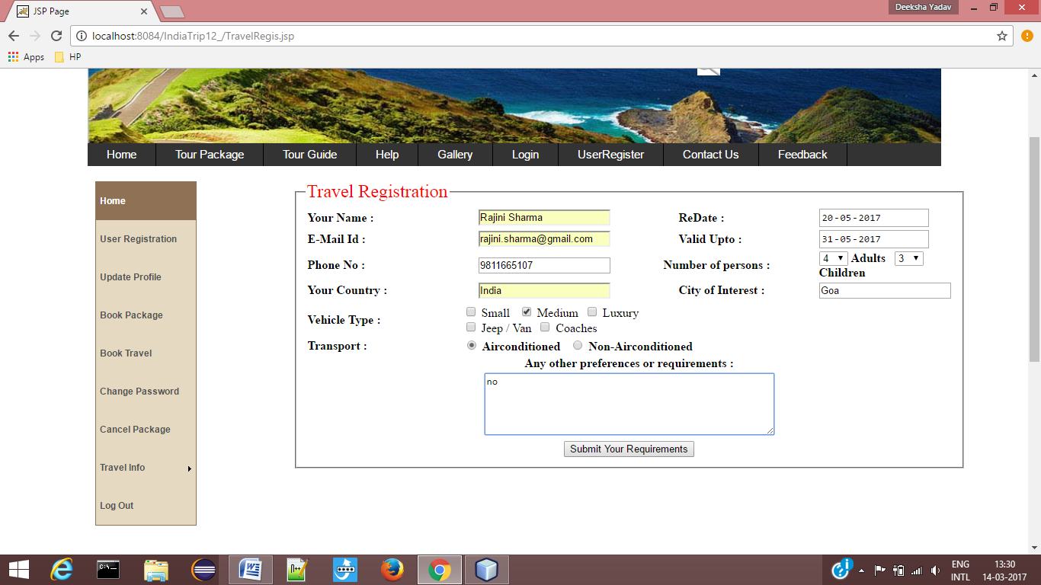

Screenshot 8.4 : For Travel Registration

Login Form

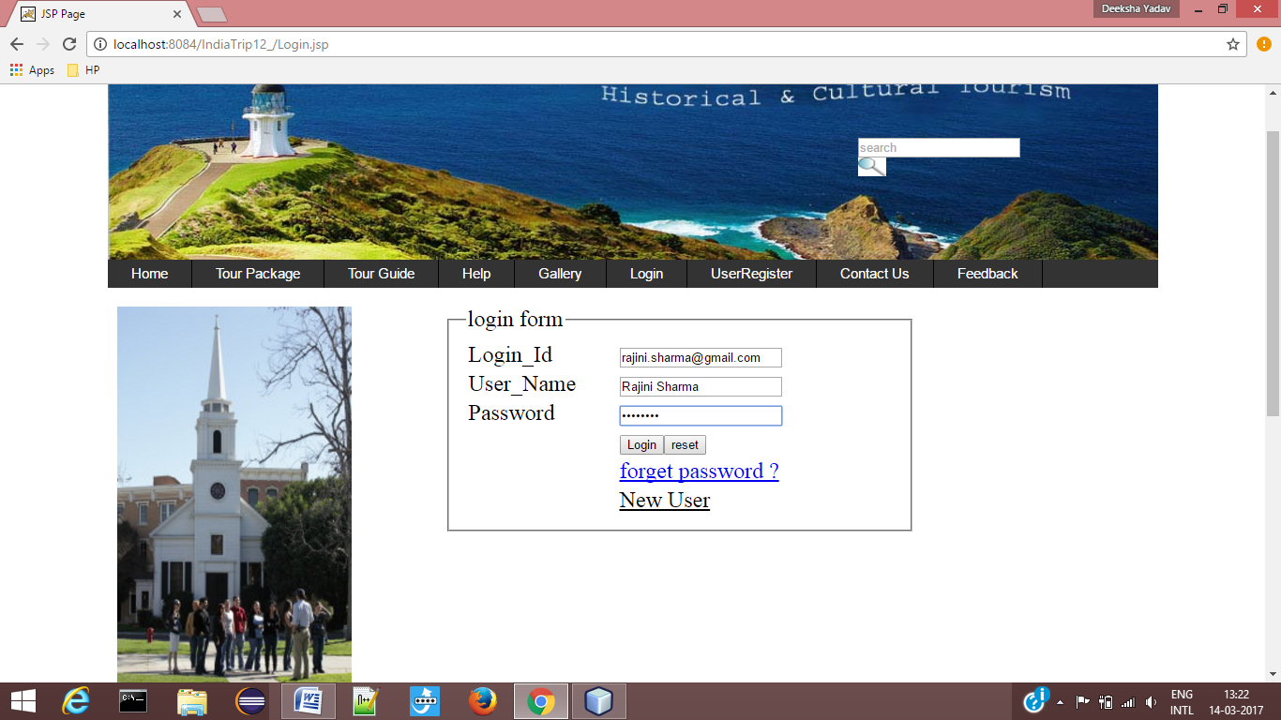

Screenshot 8.5 : Login Form

Forget Password Form

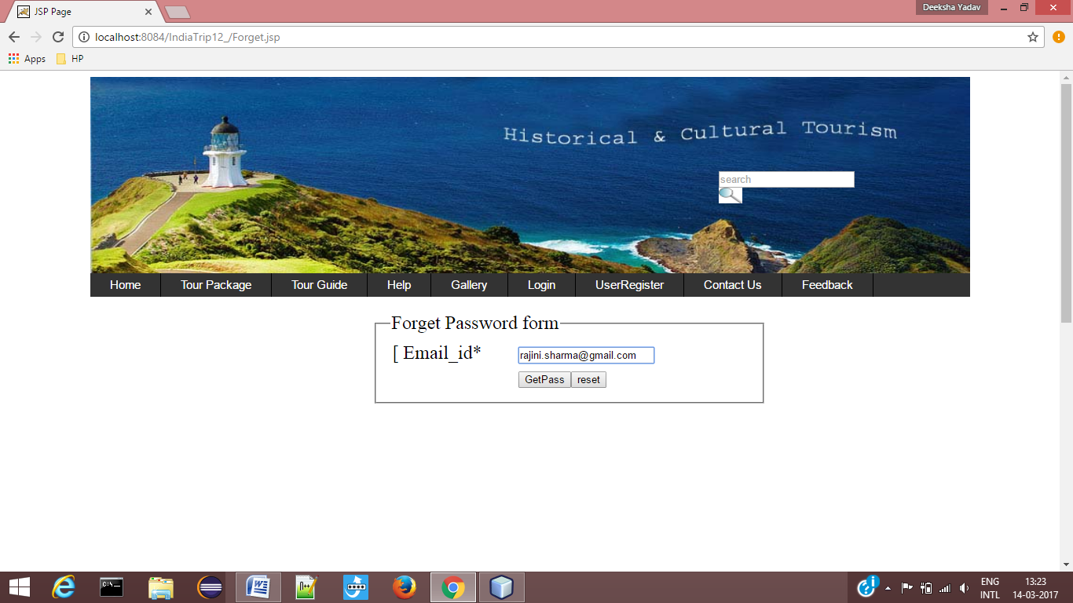

Screenshot 8.6 : Forget Password Form

Change Password

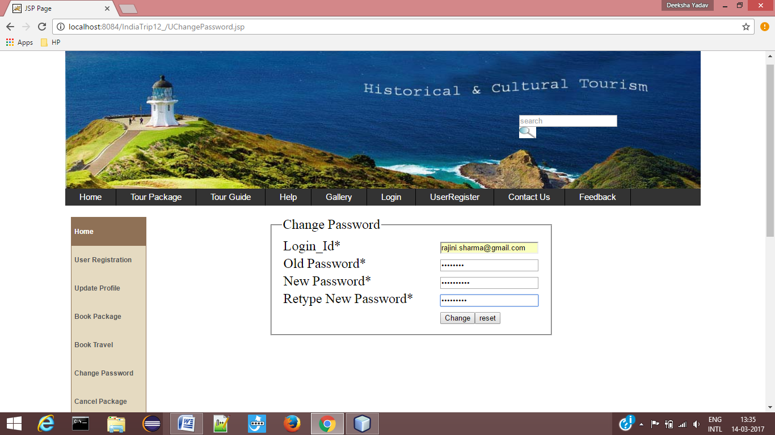

Screenshot 8.7 : Change Password Form

Cancel Package

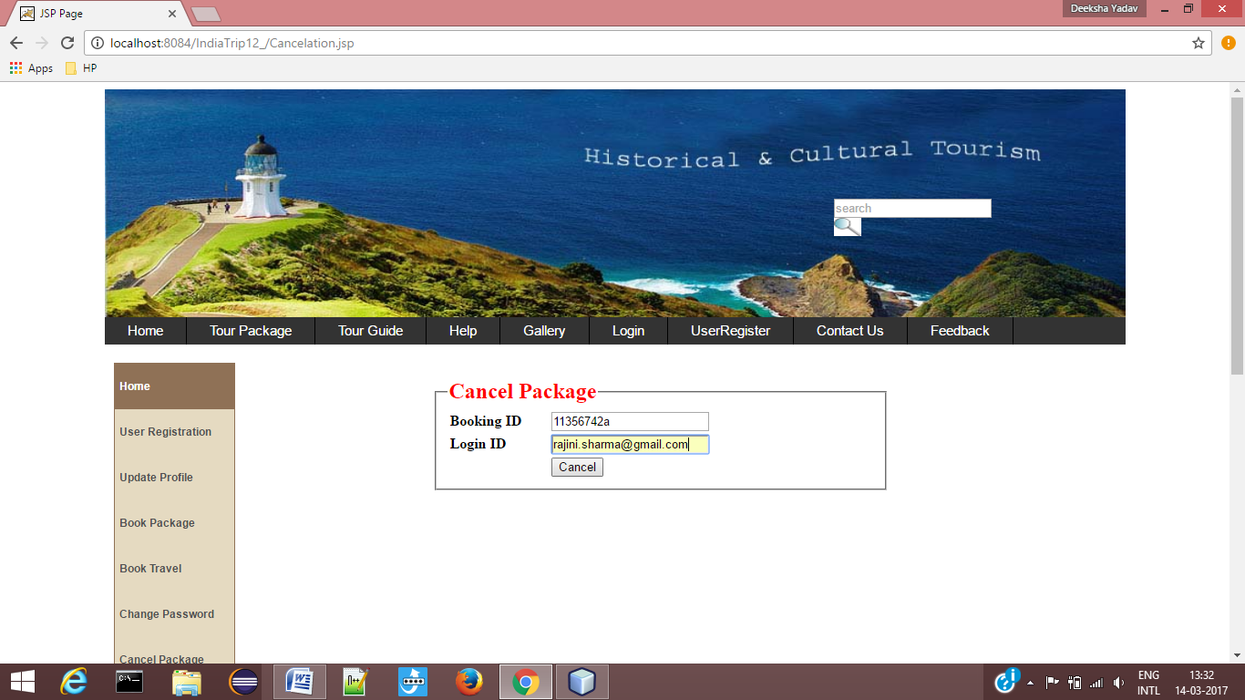

Screenshot 8.8 : Cancel Package Form

Feedback

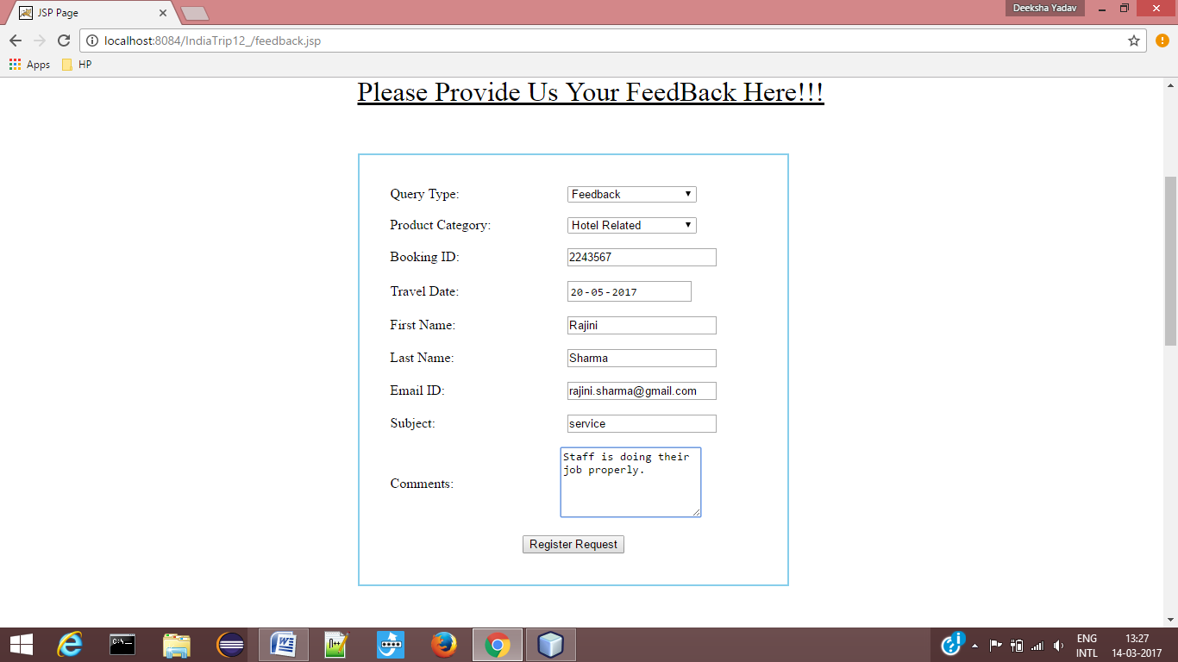

Screenshot 8.9 : Feedback form

Tour Guide

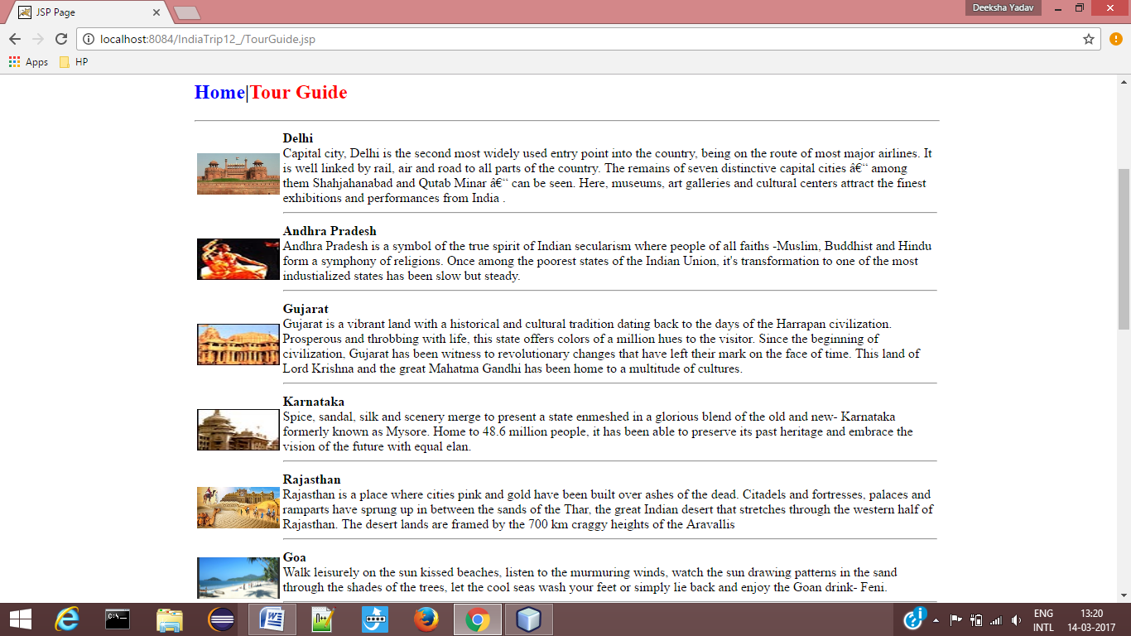

Screenshot: 8.10

REFERENCES

[1] Basham Bryan, Sierra Kathy and Bates Bert, "Headfirst Servlet and JSP", Headfirst publication, 2008-09
[2] Bayross Ivan, "Web Enabled Commercial Application Development" 2009-2010
[3] Aggarwal K.K. and Singh Yogesh, "Software Engineering", New Age Publication, 3rd Edition 2005-06
[4] Servlet Java T Point [Online]. Available: "Javatpoint - A Solution Of All Technology". www.javatpoint.com/requestdispatcher-in-servlet.

[5] JSP Java T Point [Online]. Available: "Javatpoint - A Solution Of All Technology" www.javatpoint.com/application-implicit-object

[6] JSP API Java T Point [Online]. Available: "Javatpoint - A Solution Of All Technology" http://www.javatpoint.com/jsp-api

[7] Ajax Tutorial Java T Point [Online]. Available: "Javatpoint - A Solution Of All Technology" www.javatpoint.com/ajax-example-with-database

[8] E-Mail API Java T Point [Online]. Available: "Javatpoint - A Solution Of All Technology" www.javatpoint.com/example-of-sending-email-using-java-mail-api-through-gmail-server

