A COLLOQUIUM REPORT

ON

GLOBAL POSITIONING SYSTEM”

SUBMITTED BY

DEEPIKA SINGH

1403213030

INFORMATION TECHNOLOGY DEPARTMENT,
ABES ENGINEERING COLLEGE, GHAZIABAD

* 2015-2016 *

ABES ENGINEERING COLLEGE, GHAZIABAD

Department of Information Technology

CERTIFICATE

This is to certify that Mr./Ms Deepika Singh, Roll No. 1403213030 , has successfully completed Colloquium seminar on 8th March 2016 upto satisfaction level and submitted the same during the academic year 2015-2016 towards the Course requirement, under the Department of Information Technology, ABES Engineering College, Ghaziabad.

Prof.(Dr.) P.C.Vashist

Colloquium Coordinator HOD-IT

ABES ENGINEERING COLLEGE, GHAZIABAD

Department of Information Technology

ACKNOWLEDGEMENT

I hereby btech declare that I have done this work to the best of my knowledge and ability. I have put in a lot of effort on my part to successfully complete this report entitled-
GLOBAL POSITIONING SYSTEM
I, further declare that my project is completed in all respects and this project is an effort of my study and research. I would like to thank my guide Mr Sanjeev Kapoor and Mr Saurabh Srivastva in helping me in entire manner.

Deepika Singh
1403213030
IT-A

INDEX

Table of Figures
Abstract

- Introduction of GPS 7
- Origin of GPS 8
- Structure of GPS 9
- Space Segment 10
- Control Segment 11
- User Segment 11
- Primary Functions of GPS 11
- Components of GPS 12
- Working of GPS 14
- Factors Affecting GPS Accuracy 16
- Local Effects 16
- Atmospheric Effects 16-17
- Increasing GPS Accuracy 18
- A-GPS 18
- Applications of GPS 19

TABLE OF FIGURE

S.NO. FIGURE PAGE NO.
1. Orbital plains around earth 5
2. Block Diagram 8
3. Structure of GPS 9
4. Functioning of GPS 10
5. AT MEGA Micro Controller 12
6. LCD 12
7. Capacitor 12
8. GPS Module 12
9. IC 7805 12
10. Distance between Receiver and GPS Satellite 13
11. Working of GPS 14
12. Multipath Error 17
13. Poor Dilution of GPS 17
14. Good Dilution of GPS 17
15. Assisted GPS 18
16. Applications of GPS 19-20

ABSTRACT

Global Positioning System (GPS) is the only system today able to show ones own position on the earth any time in any weather, anywhere. This paper addresses this satellite based navigation system at length. The different segments of GPS viz. space segment, control segment, user segment are discussed. In addition, how this amazing system GPS works, is clearly described. The various errors that degrade the performance of GPS are also included. DIFFERENTIAL GPS, which is used to improve the accuracy of measurements, is also studied. The need, working and implementation of DGPS are discussed at length. Finally, the paper ends with advanced application of GPS
INTRODUCTION

- Global Positioning System (GPS) is satellite based navigation system.
- It is based on a constellation of about 24 satellites.
- It is developed by the United States Department of Defense (DOD)
- It can provide accurate positioning 24 hours a day, anywhere in the world.
- There is no subscription fees or setup charges to use GPS.
- GPS satellites also called NAVSTAR, the official U.S. Department of Defense name for GPS.
- It permits land, sea and airborne users to determine their three-dimensional position, velocity and time.
- The main principle behind the GPS system- A transmitter high above the Earth sending a high-frequency radio wave with a special coded signal can cover a large area and still overcome much of the "noise" encountered on the way to the ground.

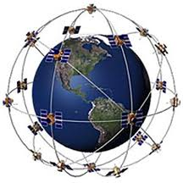
Figure 1

BLOCK DIAGRAM

Figure 2

ORIGIN OF GPS

- In the early 20th century several radio-based navigation systems were developed.
- One drawback of using radio waves generated on the ground is that you must choose between a system that is very accurate but doesn't cover a wide area, or one that covers a wide area but is not very accurate.
- GPS has its origins when scientists were able to track the satellite with shifts in its radio signal known as the "Doppler Effect".
- Roger Lee Easton, was an American scientist/physicist who was the principal inventor and designer of the Global Positioning System (GPS).
- It became fully operational in year 1995.
- GPS technology was initially developed in the United States for defence purposes
- The first launch was of Navigation System with Timing and Ranging (NAVSTAR) satellite in February 1978, 38 years ago.
- The GPS navigation system can track a person or object fitted with GPS equipment irrespective of which part of the globe they’re in.
- The tracking range is quite accurate with a usual error range of about 100 meters.

STRUCTURE OF GPS

GPS has 3 parts: the space segment, the user segment, and the control segment. . The space segment consists of 24 satellites, each in its own orbit 11,000 nautical miles above the Earth. The user segment consists of receivers, which you can hold in your hand or mount in your car. The control segment consists of ground stations (five of them, located around the world) that make sure the satellites are working properly.

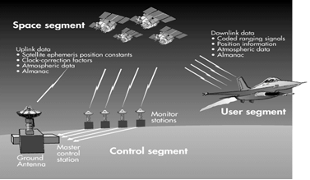
Figure 3

FUNCTIONING OF THE SEGMENTS

Space Segment
The complete GPS space system includes 24 satellites, 11,000 nautical miles above the Earth, which take 12 hours each to go around the Earth once (one orbit). They are positioned so that we can receive signals from six of them nearly 100 percent of the time at any point on Earth. There are six orbital planes (with nominally four Space Vehicles in each), equally spaced (60 degrees apart), and inclined at about fifty-five degrees with respect to the equatorial plane.
Satellites are equipped with very precise clocks that keep accurate time to within three nanoseconds. This precision timing is important because the receiver must determine exactly how long it takes for signals to travel from each GPS satellite. The receiver uses this information to calculate its position.

Figure 4
Three Segments of the GPS

Control Segment

The control segment consists of a worldwide system of tracking and monitoring stations.The 'Master Control Facility' is located at Falcon AFB in Colorado Springs, CO. The monitor stations measure signals from the GPS satellites and relay the information they collect to the Master Control Station. The Master Control Station uses this data to compute precise orbital models for the entire GPS constellation. This information is then formatted into updated navigation messages for each satellite.

User Segment

The user segment consists of the GPS receivers, processors and antennas utilized for positioning and timing by the community and military. The GPS concept of operation is based on satellite ranging. Users figure their position on the earth by measuring their distance to a group of satellites in space. Each GPS satellite transmits an accurate position and time signal. The user's receiver measures the time delay for the signal to reach the receiver. By knowing the distance to four points in space, the GPS receiver is able to triangulate a three-dimensional position

Four Primary Functions of GPS

- Position and coordinates.
- The distance and direction between any two waypoints, or a position and a waypoint.
- Travel progress reports.
- Accurate time measurement.

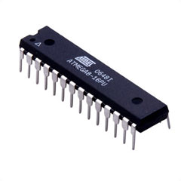
COMPONENTS
Figure 5

- GPS Tx & Rx {433MHz}
- Two AT MEGA 8 Microcontrollers
- AVR 4 Studio’s
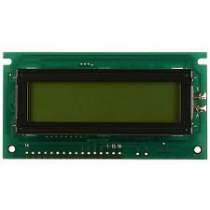
- Resistances-{4.7K}
Figure 6
- Capacitors-{10µF}
- Two LCD’s
- GPS-Module
- IC 7805
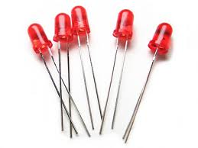
Figure 7

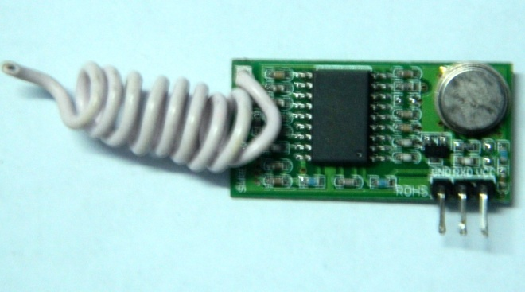
Figure 8

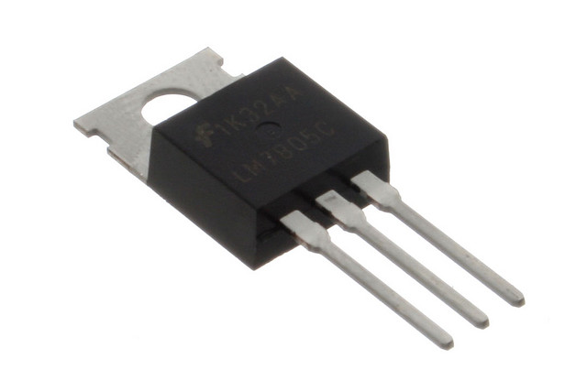
Figure 9

How GPS Determines a Location

Things which need to be determined:
- Current Locations of GPS Satellites
- The Distance Between Receiver’s Position and the GPS Satellites
Current Locations of GPS Satellites
- GPS satellites are orbiting the earth at an altitude of 11,000 miles.
- The orbits, and the locations of the satellites, are known in advance.
- GPS receivers store this orbit information for all of the GPS satellites in an ALMANAC*.
Distance Between Receiver’s Position & the GPS Satellites
- By measuring the amount of time taken by radio signal (the GPS signal) to travel from the satellite to the receiver.
- Radio waves travel at the speed of light, i.e. about 186,000 miles per second.
- The distance from the satellite to the receiver can be determined by the formula “distance = speed x time”.

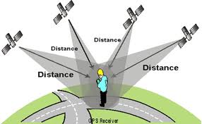
Figure 10

Working of GPS:
- GPS receiver gets a signal from each GPS satellite, it knows the exact position of satellite in the sky, at the moment they sent their signals.
- The GPS signal from 3 satellite & their exact position in the sky leads the receiver to determine the position in 3 dimensions- East, North and Altitude.
- The GPS receiver needs to know the time very accurately and so GPS satellites have atomic clocks that keep very precise time.
- To determine the location of GPS satellite there are 2 types of data which are – ALMANAC and EPHEMERIS
- ALMANAC contains information of the status of satellites and approx. orbital information to calculate which satellite are currently visible.
- EPHEMERIS gives very precise information about orbit of each satellite. GPS receiver use it to calculate the location of a satellite, it is updated every 2hrs and is usually valid for 4 hrs.
- Then it encodes this information into a standard format and transmits to the roving receivers.
- The roving receivers get the complete list of errors and apply the corrections for the particular satellites they're using.
Figure 11
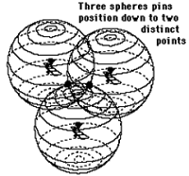
.

- It works something like this: If we know our exact distance from a satellite in space, we know we are somewhere on the surface of an imaginary sphere with radius equal to the distance to the satellite radius.
- If we know our exact distance from two satellites, we know that we are located somewhere on the line where the two spheres intersect.
- And, if we take a third measurement, there are only two possible points where we could be located.
- By taking the measurement from the fourth satellite we can exactly point out our location.

LIMITATIONS OF GPS:
GPS can provide worldwide, three-dimensional positions, 24 hours a day, in any type of weather. However, the system does have some limitations. There must be a relatively clear "line of sight" between the GPS antenna and four or more satellites. Objects, such as buildings, overpasses, and other obstructions, that shield the antenna from a satellite can potentially weaken a satellite's signal such that it becomes too difficult to ensure reliable positioning. These difficulties are particularly prevalent in urban areas. The GPS signal may bounce off nearby objects causing another problem called multipath interference.

FACTOR AFFECTING GPS ACCURACY

LOCAL EFFECTS
- RECIVER CLOCK ERROR
- SKY VISIBILITY
- SATELLITE GEOMETRY
- MULTIPATH ERROR
- ELLIPSOD

ATOMOSPHERIC EFFECTS

- IONOSPHERIC EFFECTS
- TROPOSPHERIC EFFECTS
Different errors can cause a deviation of +/- 50 -100 meters from the actual GPS receiver position which are :

ATMOSPHERIC CONDITIONS:
- Speed of GPS signal is affected by ionosphere & troposphere.
- Which cause a deviation of 0 to 30 m. from the actual position of receiver

EPHEMERIS ERRORS:
- The predicted changes in the orbit of a satellite.
- Which cause a deviation of 0 to 5 m. from the actual position of receiver

CLOCK DRIFT
- Due to different code generations in satellite and receiver simultaneously.
- Which cause a deviation of 0 to 1.5 m. from the actual position of receiver

MULTIPATH:
- Bouncing of GPS signal due to a reflecting surface before reaching to receiver antenna.
- Which cause a deviation of 0 to 1 m. from the actual position of receiver

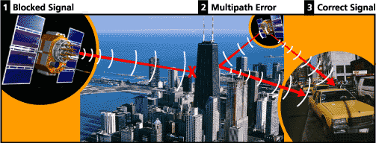
Figure 12

Measuring GPS Accuracy
The geometry of the constellation is evaluated by Dilution Of Precision, or DOP

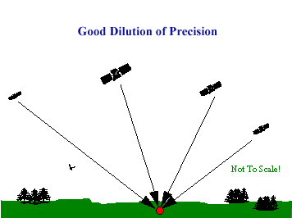
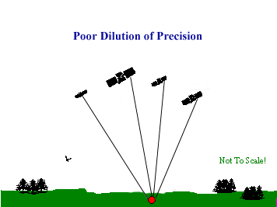

Figure 13
Figure 14

INCREASING ACCURACY OF GPS
- Differential correction provides accuracy within 1-5 m.
- Coarse Acquisition receiver provides accuracy within 1-5m.
- Carrier Phase receivers provides accuracy within 10-30 cm.
- Dual-Frequency receivers are capable of providing sub-centimeter GPS position accuracy.

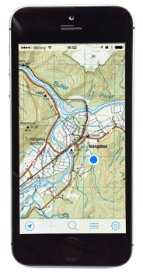
Figure 15
A-GPS

Assisted GPS (A-GPS)is used as a way of improving the time to first fix, or even allowing a fix in conditions where the GPS might not otherwise be able to function.
The A-GPS device will use a data connection (e.g. 3G on a cell phone) to contact an assistance server. The server can supply almanac and ephemeris data so the GPS doesn't have to wait to receive them from the satellites. The server can also send an approximate location derived from cell phone towers, allowing an immediate fix. In some cases the A-GPS device may send incomplete GPS data to the server for processing into a fix

Applications of GPS

- GPS receivers were used in several aircraft, including F-16 fighters, KC-135 aerial refuel, and B-2 bombers; Navy ships used them for rendezvous, minesweeping, and aircraft operations.
- It has become important for nearly all military operations and weapons systems .
- It is used on satellites to obtain highly accurate orbit data and to control spacecraft orientation.
- GPS is based on a system of coordinates called the World Geodetic System 1984 (WGS 84). The WGS 84 system provides a built-in frame of reference for all military activities, so units can synchronize their maneuvers.
- GPS is also helping to save lives. Many police, fire, and emergency medical service units are using GPS receivers to determine the police car, fire truck, or ambulance nearest to an emergency, enabling the quickest possible response in life-or-death situations.

DISASTER RELIEF AVIATION

MARINE SPACE

TIMING RAILWAYS
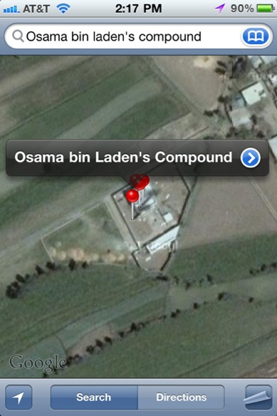 Figure 16
DEATH OF OSAMA BIN LADEN

CONCLUSION
GPS, a satellite based navigation system, thus can be used to determine the position of an object on earth. As discussed above, its application field is vast and new applications will continue to be created as the technology evolves. GPS can also interface with other similar projects such EU’s GALILEO to account for unpredictable applications. Thus, the GPS constellation, like manmade stars in the sky, can be used for guiding and navigation.

